Ideation Phase: - Empathize Discover: -

|  |  |
| --- | --- |
| Date | 20 June2025 |
| Team ID | LTVIP2025TMID50794 |
| Project Name | Measuring the Pulse of Prosperity: An Index of Economic Freedom Analysis using Tableau |
| Maximum Marks | 4 Marks |

Empathy Map Canvas: -

Creating an effective solution requires understanding the true problem and the person who is experiencing it. The exercise of creating the map helps participants consider things from the user’s perspective along with his or her goals and challenges.

**Example: -**

An empathy map is a simple, easy-to-digest visual that captures knowledge about a user’s behavior’s

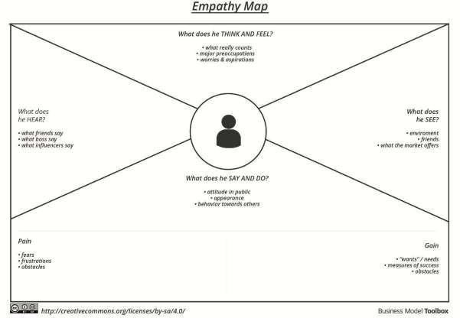

**Example: -** Measuring the Pulse of Prosperity: An Index of Economic Freedom Analysis using Tableau

